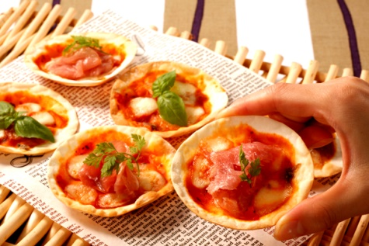

Party will be held at Yokohama Hostel Village

September 23th (sat) 6pm~10pm

\*+.・Party food menu・.+\*

・Mini Pizza

・Fried chicken

・French fries and Drinks !!

1000yen per person, if you are a student --500yen

Your Birthday is in September –Free !

If you want to join us, plz contact us. TEL:045-663-3639